TASTE OF

WINE & FOOD
By Frank Mangio

Week of September 30, 2018

5 Reasons to Like Vigilucci’s Gourmet Market

A step inside the door of the one-of-a-kind Vigilucci’s Gourmet Market in Carlsbad Village offers you 5 ways to enjoy Italian style dining.
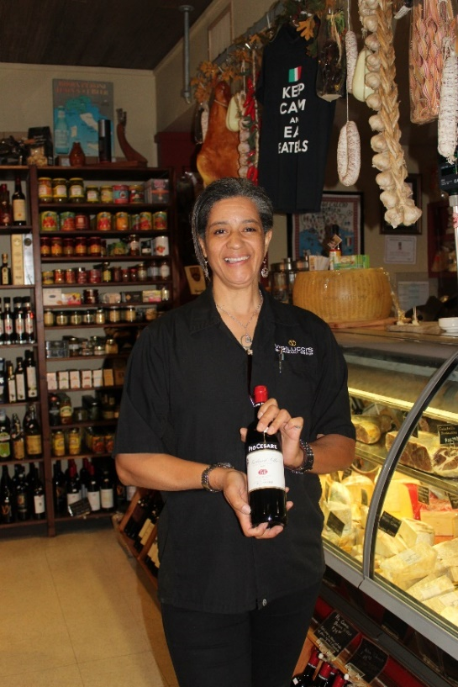

First thing you’ll notice is the deli section with fresh scents of cheeses, sliced meats, garlic, olive oil and a host of menu items blended with the Vigilucci style of Bolognese sauces.

Then your eyes will light up at the significant inventory of Italian and other wines, almost everywhere you look.

Then you will meet the lovely manager of this treasured market, Maia Martinelli, who will quickly become your best new friend and show you the daily lunch specials ranging from Panini sandwiches, meat and cheese boards to luscious Lasagna served with a mixed green salad. Rows of grocery products from Italy will give you lots of choices to make your next meal truly Italian flavored. The 5th reason to like this unique market is its Italian-style

Maia Martinelli is the manager of Vigilucci’s Gourmet

Market in the Village of Carlsbad. She is shown presenting
the popular Italian Barbera red from Pio Cesare in Piedmont.

Catering. Roberto (or Roby as his friends call him) Vigilucci has been serving

North San Diego since 1994 when he opened his first restaurant in Encinitas.

At one time, he had 8 locations in the San Diego area, but now concentrates his success to Carlsbad and Leucadia. “There is something different about Roby’s style that you want to learn from,” revealed Martinelli. “He believes in service to his customers and the Gourmet Market is his unique creation, and catering is his passion.” You can stop by the market and pick up food and wine, or the catering team can plan and take care of all the details for you from a vast catering menu that can include planning, staff, set up and break down.

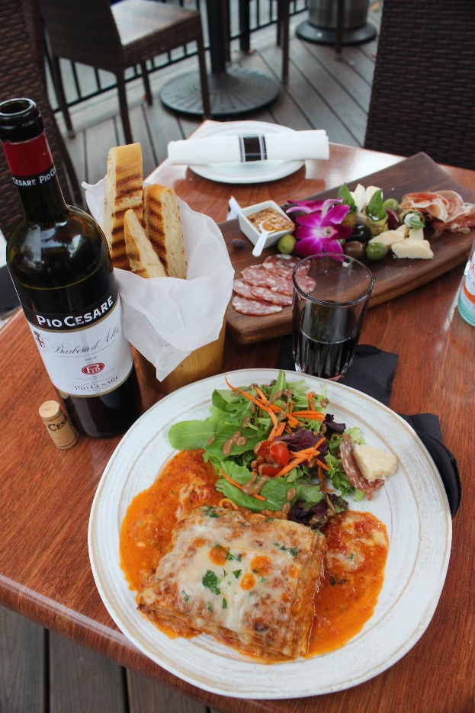
A plate that is sure to please starts with the home made bread sliced into easy to handle breadsticks. There are many choices of meat and cheese boards to select from, and Salami and Prosciutto are sure to be part of all of them. Cheeses are prominently from Parma Italy. Expect Parmigiano-Reggiano, aged 36 months, and more. Then there is the main entrée, as pretty as a picture baked Lasagna, filled with Bolognese and Besciamella sauce, topped with Mozzarella and Parmigiano cheese. It’s served with a fresh mixed green salad.

And here is the beautiful thing. That meal is part of the catering menu plus its a lovely selection every day in the market menu where you can enjoy an outdoor table with your selection, from 11 to 4pm.

Now we come to the wine that I would

The essence of a hearty lunch at Vigilucci’s Gourmet

Market & Catering in Carlsbad Village is

the meat and cheese board, baked Lasagna with

mixed green salad and a bottle of Pio Cesare Barbera

D’Alba from Piedmont, Italy.

recommend. You cannot separate wine and food. They have their arms wrapped around each other, and never more true than Lasagna and a Pio Cesare

Barbera D’Alba from Piedmont Italy, sourced from family owned vineyards in Serralunga d’ Alba. ($25.)

This smooth drinking bottle is aged in oak for 12 months producing great structure and full body fruit with earthy hints of spice.

A 6th reason to like the Market is the occasional wine events that it presents, and as it happens, their biggest show of the year is coming up Thursday, November 8th from 5 to 7pm, called “Sagra Di Vigilucci’s,” a Celebration of Food and Wine.

Wines will be Pio Cesare’s Barbara red and Villa Sparina Gavi white.

A 4 course meal is included. The cost is $35. per person. RSVP at 760-720-0188.

For more, see www.vigiluccis.com.

Wine Bytes

The La Jolla Art and Wine Festival happens Sat. Oct. 6 and Sun. Oct. 7. This is a FREE event filled with all kinds of art from 150 artists, fine wines and entertainment, in downtown La Jolla. A Wine and Beer garden will have your favorite beverage. For details, see www.ljawf.com

or call 1-619-233-5008.

The Smooth Champagne Jazz Series of concerts at Thornton Winery in Temecula continues as performer Boney James appears Sat. Oct. 13. James is currently on tour supporting his latest LP, HONESTLY. For time and pricing, see www.thorntonwine.com or call 951-699-0099.

The Winesellar and Brasserie in Sorrento Valley San Diego, will have two wine dinners with DAOU Vineyards of Paso Robles, Fri. Oct. 12 and Sat. Oct. 13 at 6pm. A 4 course dinner is planned for $89. per guest, $79. for club members.

More at www.winesellar.com.

The San Diego Bay Wine & Food Festival is coming to town the week of Nov. 12.

Many great events are planned for this 14th annual event. Sat. Nov. 17 from 12 to 3pm is the Grand Tasting at Embarcadero Marina Park North next to Seaport Village San Diego. Cost is $135. ea. Top chefs put their best bites forward in the celebrated Chef of the Fest competition. Over 300 participating exhibitors. Check all of it out at www.sandiegowineclassic.com

Frank Mangio is a renowned wine connoisseur certified

by Wine Spectator. He is one of the leading commentators

on the web. View his columns at tasteofwineandfood.com

Go to Recent Columns. Reach him at frank@tasteofwineandfood.com to comment or unsubscribe.

