
TASTE OF

WINE & FOOD
By Frank Mangio

Week of April 14, 2019

Wine Family Style and Made in California

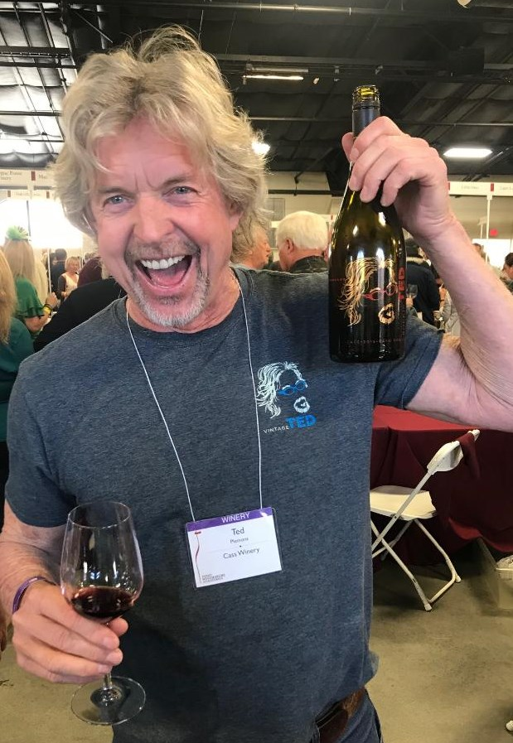
When the doors to the recent California Family Winemakers Tasting in Del Mar swung open, the thirst meter for the many in attendance went over the top. The “Family Tradition” of the largest association of California wine farmers, bottling craft wines, is increasingly attractive to a growing wine drinking public that will pay up for the experience. The Family Winemakers collected its top members and over 70 wineries, from all over the state, offered their top brands to a full house of tasters.

This is one of the few big wine shows where the owners and winemakers are eye-to-eye with the many who have come for the newest and the best of breed. Care is taken to program each of the wines in a smart and easy way, with room to

Ted Plemons, co-owner of Cass Vineyard and Winery in Paso Robles, waves his namesake

Wine, the 2015 “Rockin Ted” at the recent Del Mar Family Winemakers event.

jot down a quick assessment of each of the wines presented. From a white Alberino wine from Spain to a red Zinfandel from Paso Robles, each winery’s entry was listed with pricing, contact information and location.

Allow me to introduce a few of the standouts at the show, each with a diverse

group of wines to wet your whistle.

Ted Plemons has been rocking crowds of wine lovers with his Paso Robles based Cass Winery, since the year 2000. I could hear “Rockin Ted” from across the hall above and beyond all else. He made the most recent Taste of Wine and Food Top Ten Tastes with his 2015 Backbone Syrah, one of their distinctive Rhone Valley French style reds. It got a Double Gold at this year’s San Francisco Chronicle competition. He does make a 2015 “Rockin Ted” wine, a mix of Mourvedre, Grenache, Syrah and Petite Sirah, a full-bodied Rhone style wine with velvety tannins and baked fruit flavors. Get more info at casswines.com.

Bella Grace…now this is an Italian style winery, deep in the heart of the Sierra Foothills of Amador County. Michael Havill, the owner/winemaker offers Italian varietals like Barbera, Primitivo and Vermentino, and takes them where very few wineries will go. His 2016 Barbera, a Piemonte Italian great, also won Double Gold in San Francisco this year. See more at bellagracevineyards.com.

Coomber Family Wines is a local San Diego winery with Skip and Maureen Coomber at the helm. Founded in 2012, the Coombers managed to get involved with a custom crush and winemaking facility in Buellton (where the wine movie Sideways was made), created one of the fastest selling value wines around by converting their pet bulldog into a skateboard-rider and wine star for their “Skater Girl” wines and now they are ready to open Coomber Craft Wines Oceanside with a grand piano as the focal point. Follow this unique wine story at Coomberwines.com.

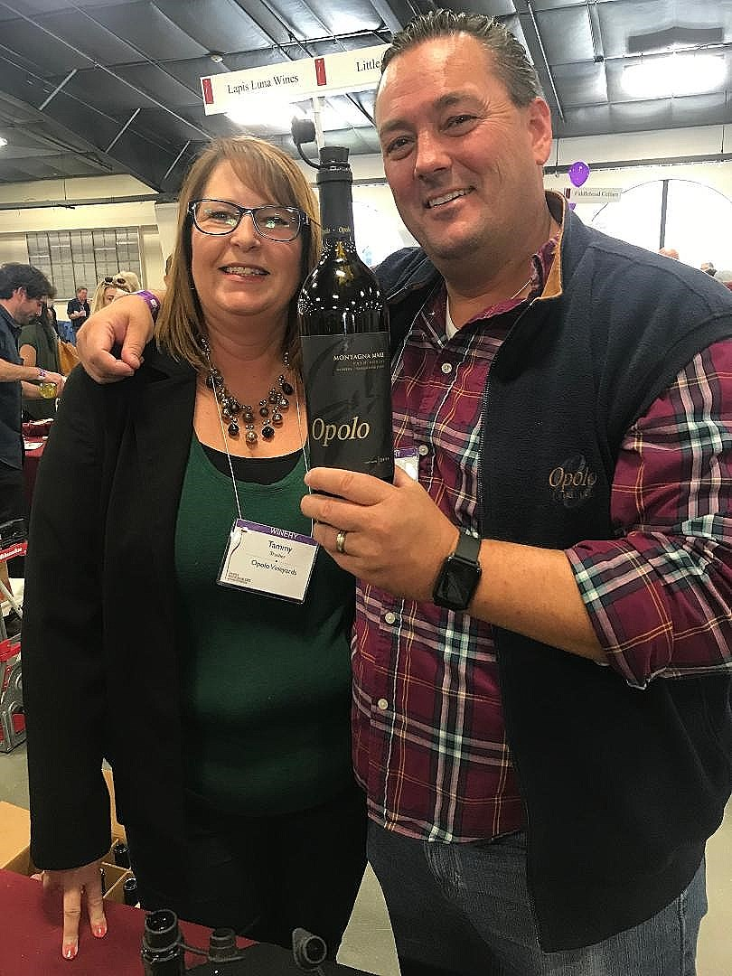
Vineyard Drive is one of the most picturesque wine country drives you will ever manage with almost endless S shaped curves through the west side of Highway 46 in Paso Robles. Finally, the Tasting Room of Opolo Vineyards, offers a welcome and some of the best Mountain Zinfandels you will ever experience. Opolo was founded by Rick Quinn and Dave Nichols, who were next door neighbors in the Southern California community of Camarillo. In 1998 they found they had a big dream in common: make the best wines with a European style based on Rick’s Yugoslavian heritage. They now manage over 270 acres split between the East and West side of Highway 101.

Tammy and Cary Thrasher lead the sales team at Opolo Vineyards, one of

the key family winemakers in Paso Robles.

Mountain Zinfandel is the go-to wine for Opolo. You will also enjoy their Sangiovese, Cabernet Sauvignon, Meritage Red and Alberino. Visit at opolo.com.

Finally a word or two about Enriquez Estate Wines in Sonoma at Forestville.

in the Russian River Valley. The family founded this winery in 2011 in Peteluma but fulfilled a dream when in 2016, they moved the winery to the Russian River district, where they could make brilliantly constructed Pinot Noir, Tempranillo and Muscat Canelli. If you love your wine cool and relaxing, then try the Sauvignon Blanc. It will set the mood for you. At 23 years old, the President and Proprietor of Enriquez Estate Wines is Cecilia Enriquez, who is as passionate a wine executive as I’ve ever seen, operating the winery for her parents.

Learn more at enriquezwines.com.

Wine Bytes

PAON Restaurant and Wine Bar in Carlsbad is presenting a premier Napa Valley wine dinner from Laird Family Estate, Wed. April 24, with a reception at 5:45pm to introduce special guest, Rebecca Laird. 6 Laird wines will be served with a paired culinary 4 course dinner experience to match. Cost is $125.each, $95. for club members. RSVP at 760-729-7377 or visit paoncarlsbad.com.

Craftsman Tavern in Encinitas is planning an “Iberian Experience,” with 6 wines from Spain and Portugal and a 5 course dinner Wed. April 24 at 6pm. Main course is a grilled Skirt Steak with Manchego-Jamon Croquetas, Asparagus and Sauce romesco. $65. per person. To attend, contact Mike at 760-452-2000.

Vittorio’s Family Style Trattoria in Carmel Valley San Diego has its monthly wine dinner Thurs. April 25 at 6pm and this one is from Justin Winery in Paso Robles. Wines will include: Sauvignon Blanc, Cabernet Sauvignon, Justification and the great Isocleles. $75. each. To RSVP, phone 858-538-5884.

North County Wine Company in San Marcos has a Goldschmidt Vineyards wine dinner, Sat. April 27 at 6pm, with top chef Erin Sealy presiding. 5 Goldschmidt wines will be poured including the top rated 2015 Goldschmidt Hillary Oakville Cabernet Sauvignon. Cost is $85. per person, $80. for NCWC wine club members. Call 619-823-3541 or contact chef@winepairsevents.com.

Frank Mangio is a renowned wine connoisseur certified

by Wine Spectator. He is one of the leading commentators

on the web. View his columns at tasteofwineandfood.com.

Go to recent columns. Reach him at frank@tasteofwineandfood.com to comment or unsubscribe.

