
TASTE OF

WINE & FOOD
By Frank Mangio

Week of August 18, 2019

The Winery is Much More than a Winery

Enter The Winery and you have arrived at a modern palatial comfortable dine and wine laid back restaurant, in a beautifully renovated outdoor shopping village, UTC, in North San Diego. What brought us to The Winery was the

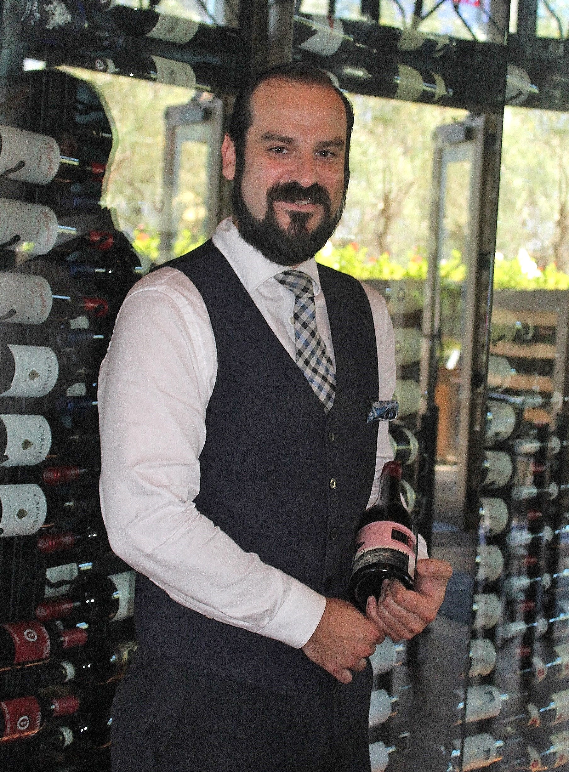
introduction of Brunch, with a wide variety of gourmet chef-created dishes each Saturday and Sunday from 11:30 to 4pm. That’s right, you can drop in for a beautifully prepared Brunch that serves as your main meal. Chef de Cuisine Danny Garcia cooked and narrated our dishes such as Zinfandel Braised Beef Shortrib Hash and Fried Eggs with Fingerling Potatoes & Mixed Greens, Almond Croissant Crème Broulee French Toast and Fresh Berries with Applewood smoked bacon. My absolute favorite was a White Shrimp Risotto with Spring English Peas, Wild Mushroom, and Crispy Prosciutto with a Pinot Noir reduction.

The Manager of The Winery is Nicholas Montanez who also

supervises the food and wine at the multi-purpose dining

restaurant in San Diego’s UTC upscale shopping district.

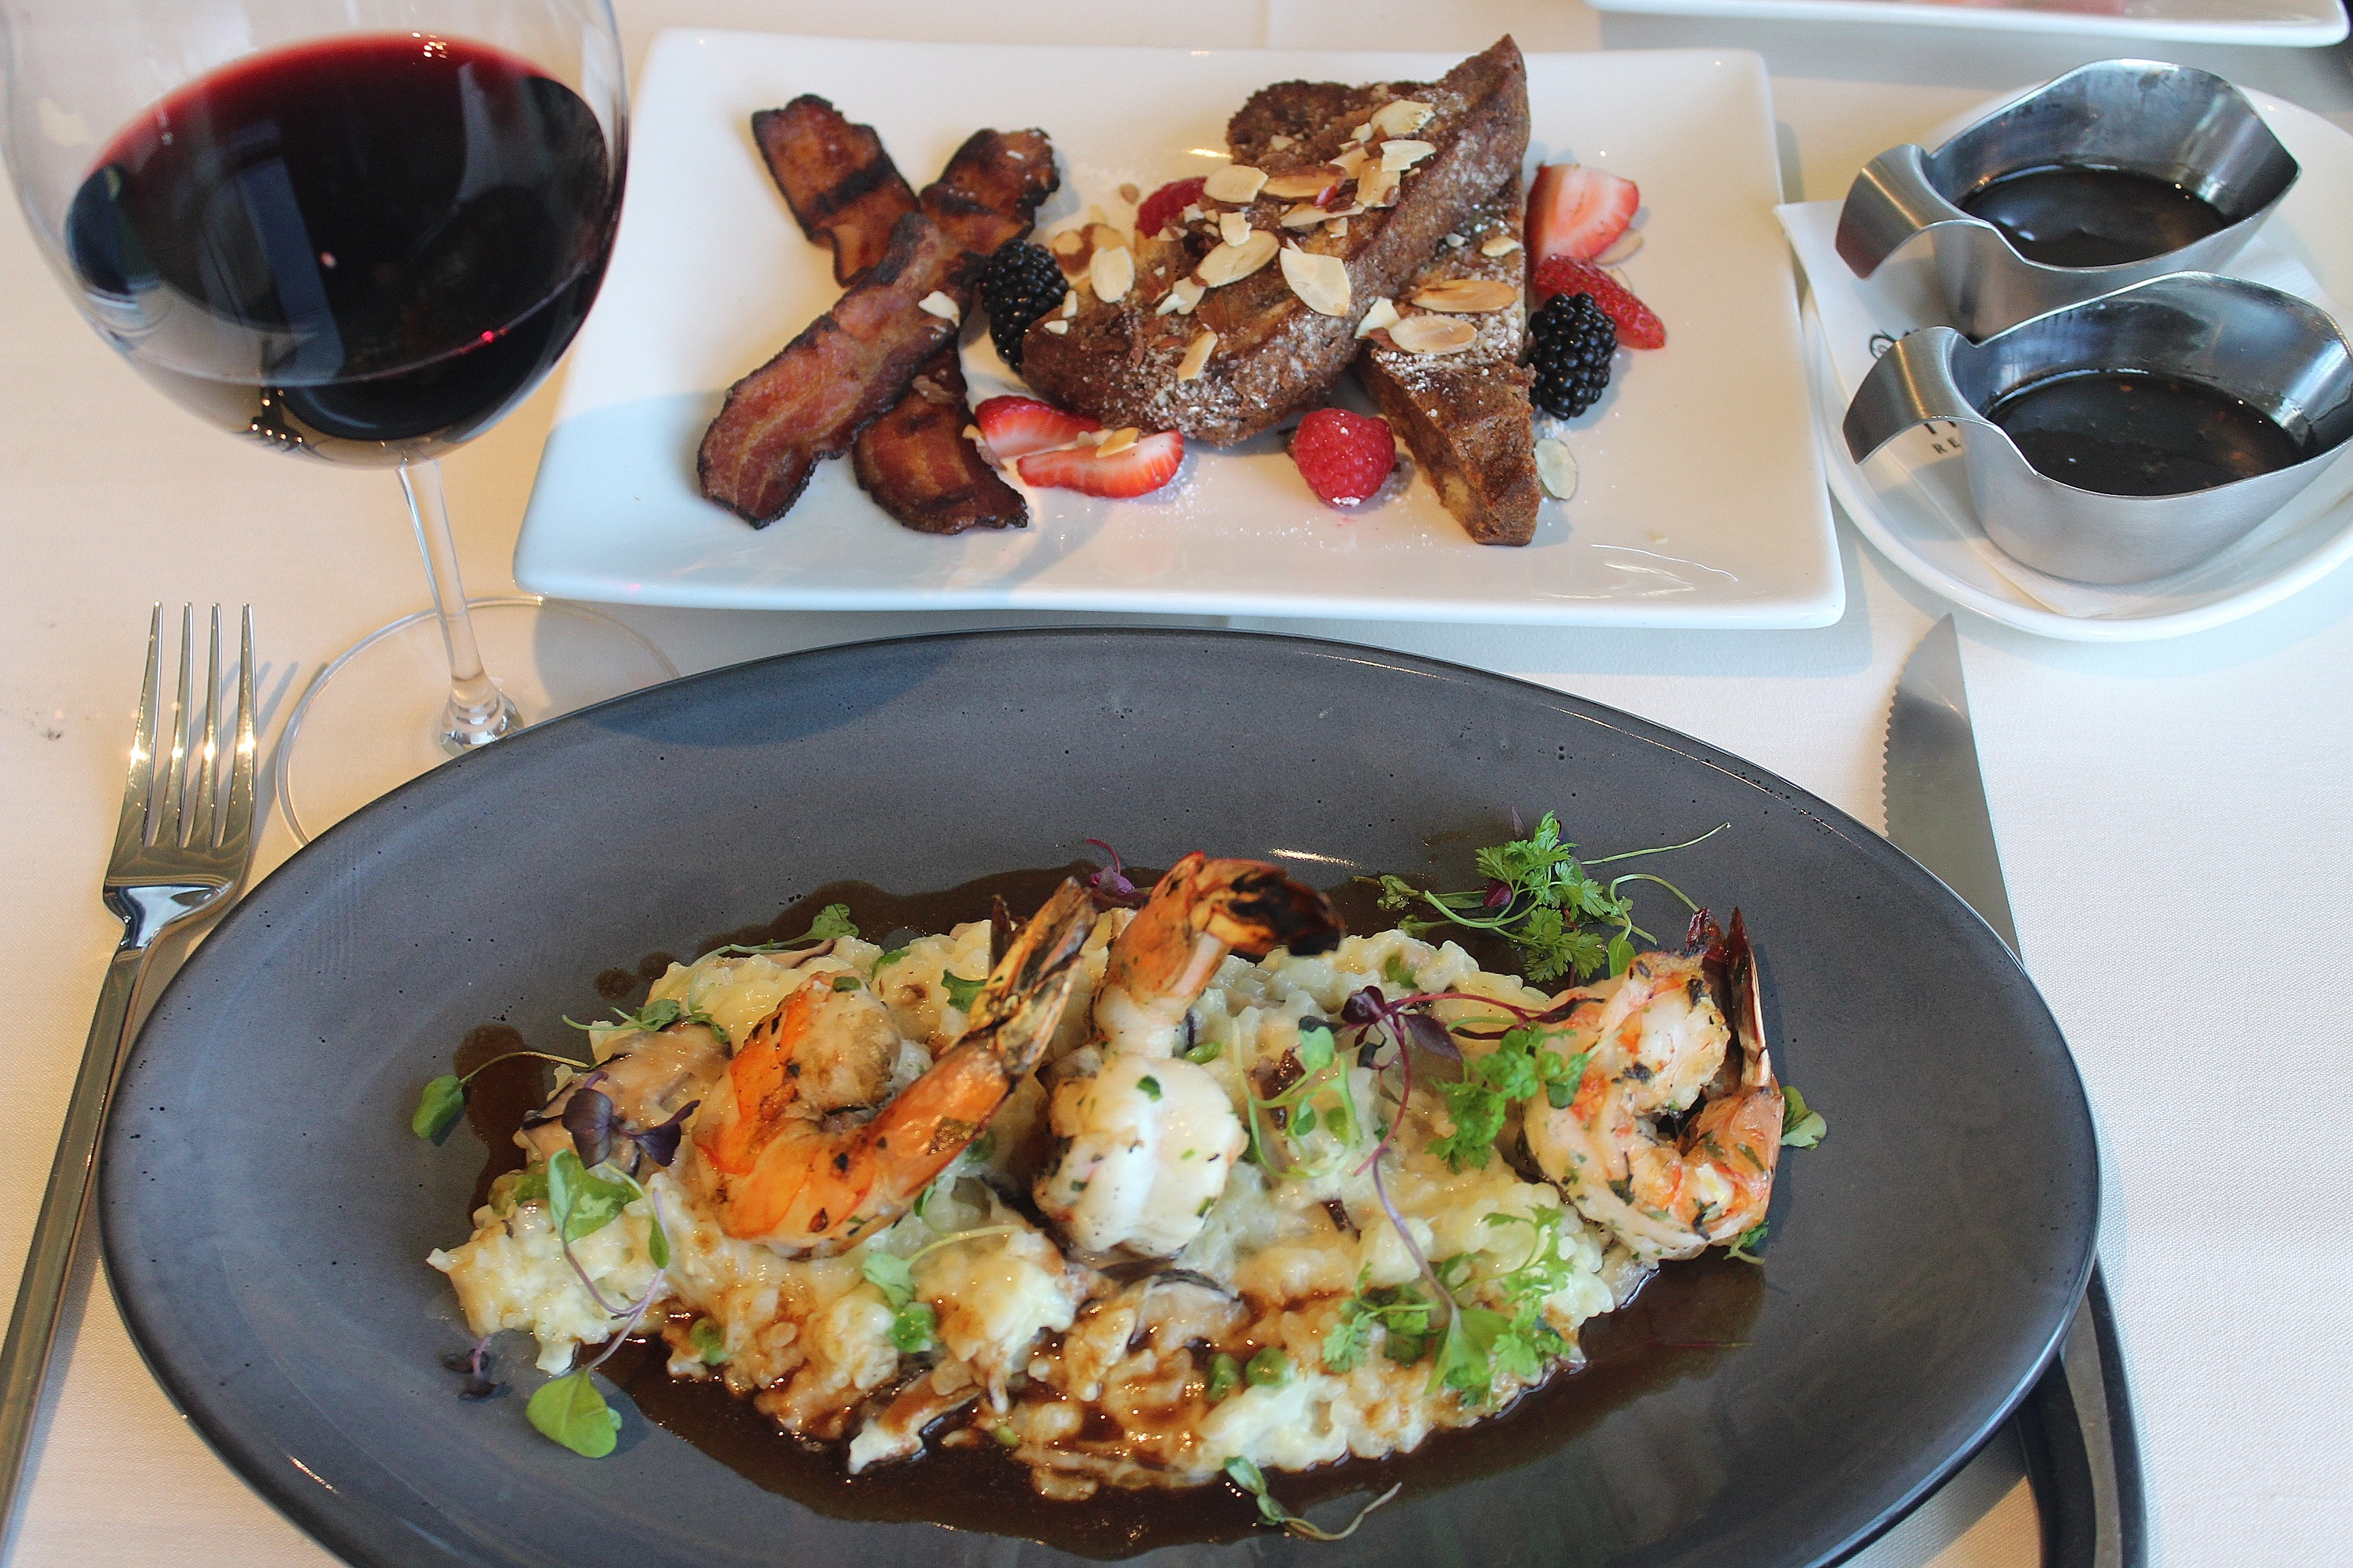
Executive Chef Yvon Goetz is one of the three original owners of The Winery delivering cutting edge quality for lunch, dinner and happy hour, with locations in Tustin, Newport Beach and San Diego. He is originally from France and can claim the AAA Five Diamond Award and multiple Chef of the Year Awards.

The new Brunch feature at The Winery has menu features like

Almond Croissant Crème Brulee French Toast, and White Shrimp

Risotto with English Peas, Wild Mushroom and Crispy Prosciutto

(both shown above).

Nicholas Montanez is the Manager of The Winery. He’s also is in charge of the food and wine buying for the restaurant. He began our tour by showing us The Wine Bar, a wine cellar adjacent to the restaurant, kind of an intimate quiet chapel with a mini bar and small bites available. “This is truly our wine cellar to relax and have a glass of your favorite wine,” he said. And great wines they are, rewarded recently by Wine Spectator with their “Best of the Award of Excellence.”

Back on the main floor of the restaurant, Montanez then took us through the tall almost circular main cellar. It takes a ladder to get to the upper reaches of his collection that begins with domestic wines. As a start up we chose a Conundrum Brut Rose’ from the Wagner Family of Napa Valley. This is the only sparkling wine that suites my taste. This is a lively, succulent strawberry flavored wine with a hint of rose petal. Next up was the Cakebread Chardonnay also from Napa Valley. The wine was vibrant, with lime and grapefruit flavors accented with delicate spice. A Hall Napa Valley Cabernet Sauvignon capped the wine flight. It had a dense core of currant and blackberry wrapped in a likable licorice

flavor, that exhibited a solid presence through to the finish.

Halter Ranch in Paso Robles has played a big role at The Winery. Their 100% Syrah, aged 18 months in French oak, is a featured wine by the glass. The 2016 vintage taste is black cherry with a trace of earthiness to it that leads to soft integrated tannins at the finish. Montanez then introduced us to “The Boyz.”

Another Halter Ranch entry on The Winery’s list, this one is produced personally with the 3 founders of the restaurant. They hand selected the grapes from blocks of the Halter Vineyard. “The Boyz” presents a unique captivating blend. Halter Ranch has recently been awarded Winery of the Year at the 2019 Central Coast Wine competition. Visit thewinerylajolla.com and halterranch.com.

Wine Bytes

South Coast Winery Resort & Spa in Temecula is the place for Jazz stars in its Rhythm on the Vine series. On Sun. Sept. 1, it’s Michael Paulo and Friends in the Vintners Garden, starting at 6:30pm. Tickets are $40. general admission, $55. for Gold seating and $85. for VIP seating. Dining is available for a nominal charge. See southcoastwinery.com/concerts.

The Newport Beach Wine & Food Festival is Thurs. Oct. 3 to Sun. Oct. 6 with the Grand Tasting Sat. and Sun. Oct. 5th and 6th, 3 to 6:30pm at the Newport Beach Civic Center. Best buys are the Platinum VIP $250. tickets with an early 2pm entrance, 250+wines, spirits and brews, 40+ highly acclaimed restaurants, live cooking demos and a Riedel wine glass. General admission ticket $150.

For details go to newportwineandfood.com

Vittorio’s Trattoria in San Diego’s Carmel Valley is offering a Seghesio Family Vineyard Four Course Wine Dinner, Thurs. Aug. 29 at 6:30pm. Enjoy the award winning wines including “Angela’s Table Zinfandel with a Beef & Spinach Braciole homemade Gnocchi. $60. per person. Call for an RSVP at 858-538-5884.

Frank Mangio is a renowned wine connoisseur certified

by Wine Spectator. He is one of the leading commentators

on the web. View his columns at tasteofwineandfood.com.

Go to recent columns. Reach him at frank@tasteofwineandfood.com

