
TASTE OF

WINE & FOOD

By Frank Mangio

Week of January 12, 2020

Here & There in the 20/20 World of Wine & Food

I just made an appointment with my optometrist so I can be part of the “eyes have it” movement in this 20/20 year of the vision. I’m already seeing it in the new projects connected to wine and food being readied for greatness.

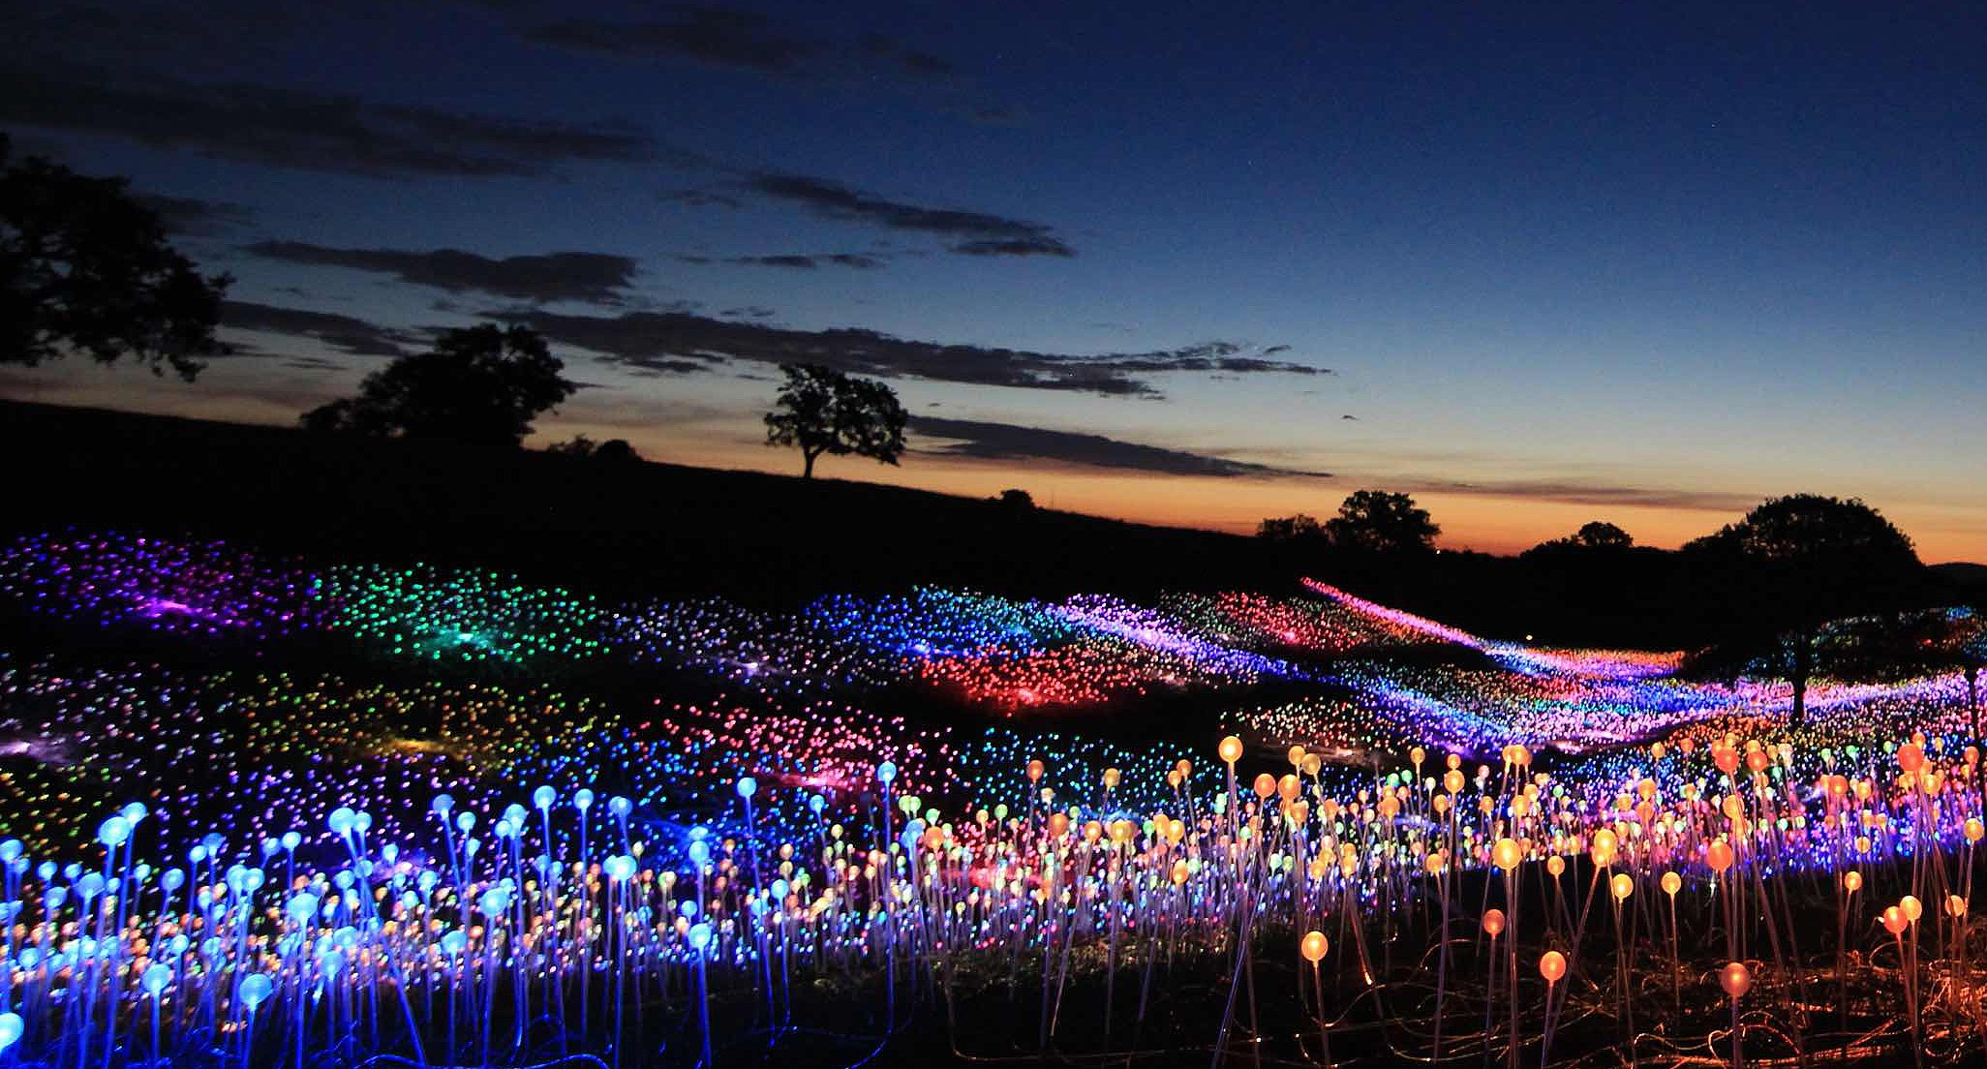
In cavernous New York City, a curious but fascinating story was recently put to bed and published in the New York Times: 52 places to go in 2020. The only place in California given the honor of this list

Paso Robles, the hidden wine country treasure in Central California

came out of the closet when the New York Times awarded it the #6 place

to go in 2020 on the strength of its Sensorio light show.

at #6, was Paso Robles in Central California, a rapidly rising wine country

district with a hip city built around its more than 300 wineries and vineyards.

What put it in this enviable position was a masterful “field of light” created by artist Bruce Munro, with 60,000 illuminated glass orbs rolling through 15 acres

of prime vineyard land east of Highway 101. There is also a rising wine hero, Daniel DAOU, who with his creative brother Georges, is ringing the Paso bell

on DAOU Mountain with stunningly different wines dedicated to family members. They also recently made a fearless purchase of an ocean view scenic property at Highway one in Cambria, 20 minutes from DAOU Mountain. It will restore a legendary restaurant, display a garden paradise and present a welcoming tasting room. The project will be called DAOU Ocean.

New Wines that may become Favorites

Just released, these 3 wines are unique, fascinating reminders that the wine industry continues to offer adventures in taste. The aforementioned DAOU, in the Adelaida District of Paso Robles, has an Estate Chardonnay of great tradition and world class elegance. The 2,200 foot elevation of DAOU Mountain with its steep slopes provide a first class drinking experience. DAOUVINEYARDS.COM.

Randy Lewis was a professional race car driver for 23 years. He raced formula 5 “Indy” cars from 1983 to 1991. Randy’s 2nd love is wine, big red wine from Coombsville Napa Valley, where he landed in the Top Ten in our annual tasting competition with his current Cabernet. His newest creation is Race Car Red, a 2017 Cab that is balanced, responsive and ready to run at a nice price. Lewiscellars.com.

I was disappointed the first time I tasted the first wines for the American market made by celebrity Italian Tenor Andrea Bocelli and his brother Alberto in Tuscany. It was little more than cooking wine. Their current effort deserves the applause it’s getting. It’s a 2015 Tenor Red, with equal parts Cabernet, Merlot and Sangiovese in a handsome gold and red label. It costs about the same as the first flunky wine, but with so much more Italian flavor. Bravo Andrea! Bocellifamilywines.com.

THE PALM SPRINGS PINOT NOIR FESTIVAL IS SAT. JAN. 18

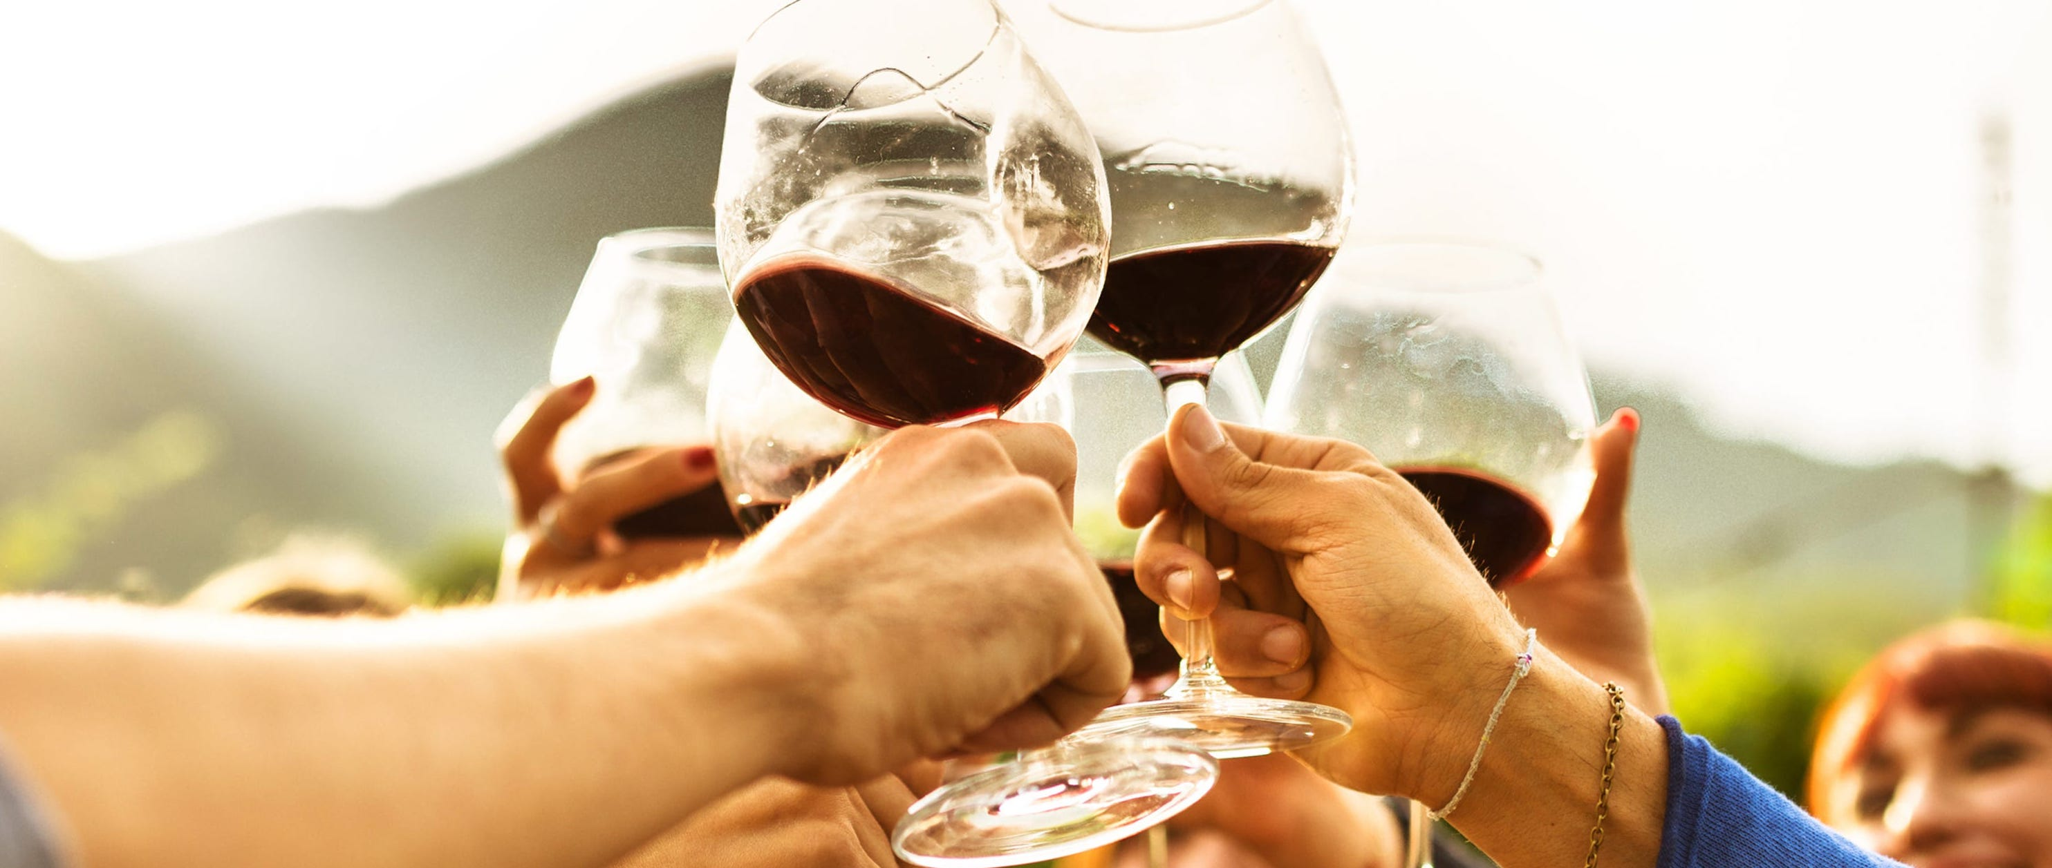

Mark the Palm Springs Pinot Noir Festival as a premier fest on the international calendar. This inaugural collective of the most desirable Pinots is the brainchild of producer Dave Fraschetti, who has made a name for himself in San Diego with his Vin Diego events.

Taste and discover new wines and current standards from Oregon and California. The Grand Ballroom of the Ritz Carlton Hotel in Rancho Mirage is the home for this “Passion 4 Pinot” celebration. Some of the best chefs in the desert from highly acclaimed restaurants and country clubs will be preparing delicious bites to enhance the beautiful, sensuous pinots. Prices range from $95. for general admission at 2:30pm, to $125. for early entry at 1:30pm. Showtime on Sat. Jan. 18th continues to 5pm. For full details, visit palmspringspinotfest.com.

Wine Bytes

Mike Cusey manages The Craftsman in Encinitas. He and Chef Sergio Serrano have put together a special Italian dinner Wed. Jan. 22 at 6pm with a special guest educator, Bryan Taylor. They are planning 5 food courses matched by 5 Italian wine gems. Signature entrée will be a Braised Short Rib enhanced by a 2014 Daniele Conterno Barolo from Piemonte. Cost is $70. per person. 30 seats are available. RSVP at 760-452-2000.

North County Wine Company starts 2020 with fantastic Happy Hour deals Tues. thru Thurs. Wines by the glass are half price from 4 to 7pm. Mark the date for Fri. and Sat. Jan. 17th and 18th when their Top 100 Wine Tasting event happens, and their famous Penny Sale is on Fri. Jan. 31. Details at 760-653-9032.

A Justin Isosceles 5 course dinner will be offered at KnB Bistro in La Jolla with Sinia Shaw from Justin and chef Erin Sealy, on Thurs. Jan. 23 from 7 to 9pm. A variety of Justin’s best will be opened, carefully prepared with the chef’s choice entrees. $85. each. Details at 619-823-3541.

Frank Mangio is a renowned wine connoisseur certified

by Wine Spectator. He is one of the leading commentators

on the web. View his columns at tasteofwineandfood.com.

Go to recent columns. Reach him at frank@tasteofwineandfood.com

