
TASTE OF

WINE & FOOD

By Frank Mangio

Week of Sept. 27, 2020

Three Night Sell Out for Caymus Wine Dinners at West End

While many local restaurants are still electing for virtual wine dinners, West End Bar & Kitchen proprietor, Sal Ercolano, is hosting live wine dinners diligently following required safety protocols for Covid. Ercolano’s latest wine dinner series featured one of Napa Valley’s most popular vineyards, family owned Caymus Vineyards. Mary Gavin, Regional Sales Manager, Southern California, and John Parker, Young’s Market, Account Manager narrated the event.

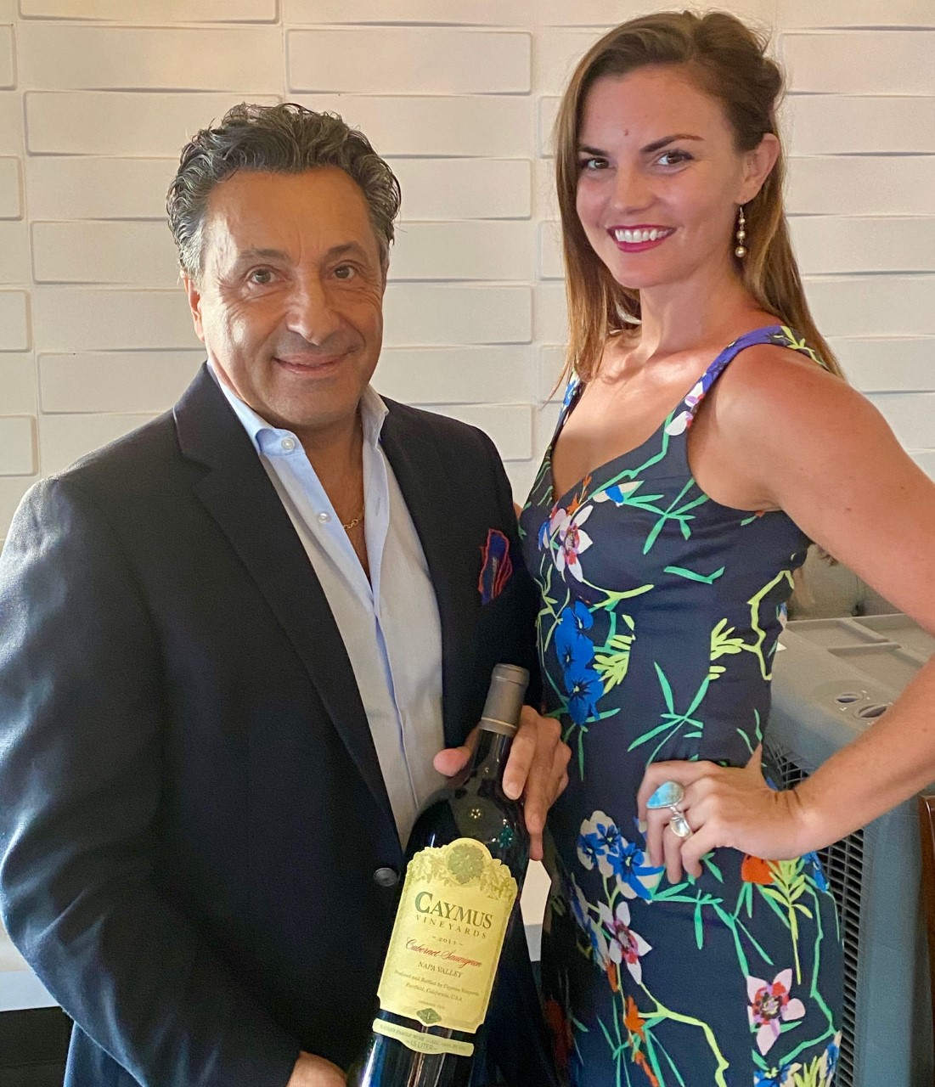
Before digging into dinner, it would only be fitting to cover a bit of history on Caymus. In 1971 Charles F. (Charlie) Wagner and his wife Lorna Belle Glos Wagner asked their son Charles J. (Chuck) Wagner, who had just graduated from high school, if he would be interested in joining them in starting up a winery. If Chuck declined the offer, Charlie and Lorna were planning to sell out of their ranch in Napa Valley and move to Australia. Chuck accepted his parents’ offer to launch the winery, Caymus Vineyards. The Wagners produced their first vintage in 1972, consisting of 240 cases of Cabernet Sauvignon. Since then, Caymus has focused

(Left to Right) Sal Ercolano, West End Bar
& Kitchen proprietor holding a 1.5 liter magnum
of Caymus Cabernet Sauvignon with Mary Gavin,
Caymus Regional Sales Director, Southern CA.

its efforts in the production of quality Cabernet Sauvignon now producing over 65,000 cases each year.

Over the years, Caymus has grown into Wagner Family Wines that also includes brands created by two of Chuck’s children, Charlie and Jenny. His other son, Joe, went on to create one of the world’s most popular Pinot Noir brands, Meiome, that he later sold to Constellation Brands for over $300M. Today, Joe has his own wine and spirits collection called Copper Cane.

The evening kicked off with Chef Noe mini bites of crab, caprese on a stick, and stuffed mushrooms paired with No. 2 Emmolo Sparkling wine created by Jenny Wagner. ”I’ve always loved sparkling wine,” she revealed. When I go to my Dad’s for dinner, he’ll often hand me a glass of bubbles to start…” The citrus and guava flavors were fresh and crisp. Next up was Mescal marinated salmon and ahi tuna carpaccio paired with Charlie Wagner’s Mer Soleil Chardonnay Reserve from Santa Lucia Highlands. This reserve chardonnay benefits from one year of French Oak barrels with a small portion seeing malolactic fermentation leaving a crisp acidity. Hand stirring of the barrels imparts a creamy texture that hangs on the palate. The third course featured killer spinach fettuccine with porcini mushrooms along with Voyage 8 Red Schooner Malbec also created by Charlie. Making Malbec was a Wagner Family goal and they knew exactly where to source their fruit, the high mountains of Argentina, the Malbec capital of the world. The fruit is picked, flash chilled, and shipped by boat. The third week journey finishes in Caymus-style wine making techniques featuring “Mendoza dust” tannins along with plum on the nose and palate. What is ingenious with Red Schooner is that South America’s wine harvest is opposite Napa Valley’s resulting in “reverse season” winemaking optimizing production equipment.

The main entrée (4th course) featured flat iron steak with roasted Brussels sprouts and creamy polenta, served with big dog Caymus Cabernet Sauvignon created by Chuck Wagner. This beautiful Cab Sauv has been dazzling wine aficionados for years. In fact the next tier up, Caymus Special Selection Cabernet Sauvignon, is the only wine in the world to have been awarded “Wine of the Year” by Wine Spectator for two separate vintages. The evening wrapped up with Torta Ricotta along with another of Chuck’s wines, Caymus Suisun Grand Durif (aka Petite Sirah) from the Suisun Valley. The Durif had deep garnet red color with dark fruit and cacao and was a perfect pairing for the chocolate in the torta. Great dinner Sal and Chef Noe and narration Mary and John. More at caymus.com.

Before closing, it is worth catching our readers up on Ercolano. The 2020 wine dinner series has three more in the lineup. Cakebread Cellars at his sister restaurant Seasalt Wed. 10/21 and Thur. 10/22, $70 per person, RSVP at 858.755.7100, followed by Chateau Montelena Thur. 11/19 and Fri. 11/20, $75 person at West End, RSVP at 858.259.5878. The series ends with a Royal Night of Schramsberg complex handcrafted sparkling wines along with Davies Vineyards at Seasalt on Wed. 12/16 and Thur. 12/17, $95 per person. RSVP at 858.755.7100. All of these West End and Seasalt wine dinners start at 6:00PM.

Ercolano will also be opening a new Italian Restaurant in Carmel Valley in mid-October where the old Amici’s used to be. The restaurant will be called Flora’s, named after his mom. Watch out Energizer Bunny, Sal Ercolano is on your tail. Bravo Sal!

Story by Tech Director/Writer Rico Cassoni

Wine Bytes
Il Fornaio in Del Mar Plaza has created a four-course Lasagna “Prezzo Fisso Speciale” for 2, available “to-go” for just $50. This is a 4-course meal layered in tradition and baked in the oven featuring fresh pasta sheets with meat ragu, porcini mushrooms and Grana Padana grated cheese. The feast is finished by Treviso-style Tiramisu. This limited time special can be ordered at 858-755-8876.
Capri Blu in the Rancho Bernardo district of San Diego brings Live Maine Lobster Dishes to its menu, available Thursdays through Saturdays while supplies last. And try Capri Blu’s new Limoncello Tartufo, a lemon ice cream with a liquid limoncello core coated with crushed merinque. Seating limited so call for an RSVP at 858-673-5100.
North County Wine Company’s Wine of the Week is an Australian McLaren Vale Blend, a 2016 Davey & Brown Vortex. It’s mostly Cabernet Sauvignon, with some Tempranillo and a splash of Grenache. Wine Enthusiast rates it 90 points. NCWC has knocked the price down to just $13.97/bottle. Call 760-653-9032.

Frank Mangio is a renowned wine connoisseur certified

by Wine Spectator. He is one of the leading commentators

on the web. View his columns at tasteofwineandfood.com.

Go to recent columns. Reach him at frank@tasteofwineandfood.com

