
TASTE OF

WINE & FOOD

By Frank Mangio

Week of January 24, 2021

Instant Pot “Tailgating” with Baby Back Ribs

A rare, good thing to come out of the Covid pandemic this year, at least for me, was my introduction and adoption of Instant Pot cooking. Based on the popularity of the Rigatoni alla Bolognese column a few weeks back, it seemed fitting to write a new column highlighting Instant Pot “Tailgating.” A clear advantage of watching a playoff game at home is having electricity to power up an Instant Pot to make some baby back pork ribs and homemade onion rings.

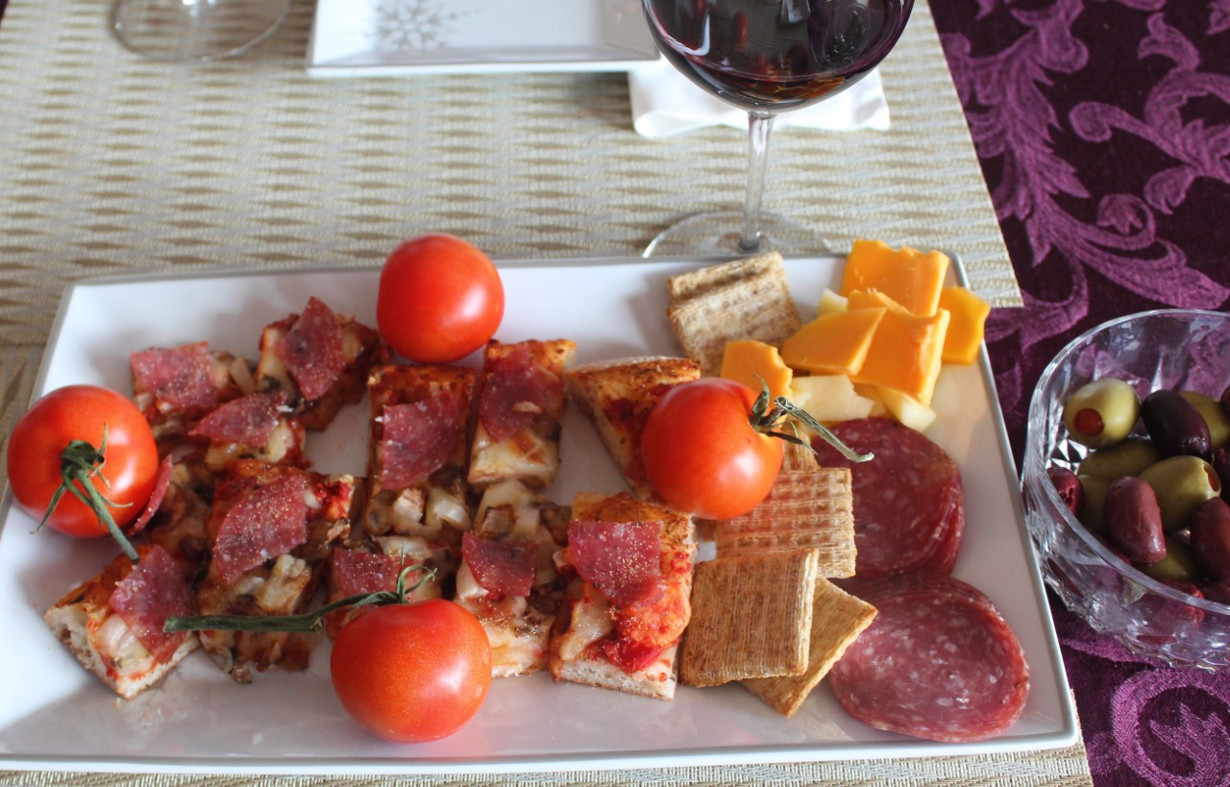
Before the ribs were made, Senior Editor Frank jumped in on the action with two rounds of appetizers. Round 1 included Borrelli’s pizza, Genoa Aged Salami, cheese and olives. Round 2 was Norwegian Salmon along with toasted French bread topped with caramel sauce. The appetizers were paired with a 2016 Joseph Phelps Napa Valley

Frank Mangio, Taste of Wine and Food
Senior Editor appetizer pizza plate with
hothouse organically grown tomatoes.

Cabernet Sauvignon. The Phelps had black fruit, anise, and coffee on the nose with a creamy texture on the palate finishing with spices, vanilla, and notes of fig well complementing the appetizer poo poos. josephphelps.com.

Just like before, I wanted to include the recipes for dishes made. It was key having a spice grinder for the spices. I rubbed the ribs with “Rico Rub,” my own dry rub concoction of 1 tsp black peppercorns roughly ground and then added 1-1/2 tsp Mesquite spice, 1 tsp “Chicken Shit” by Disparity Ranch, 1 tsp granulated garlic, 1 tsp brown sugar, and ½ tsp season salt before fully grinding the spices. The rub was applied to the ribs that had a Carolina Mustard based sauce as a binder and then I let the spices soak in for a few hours in the refrigerator.

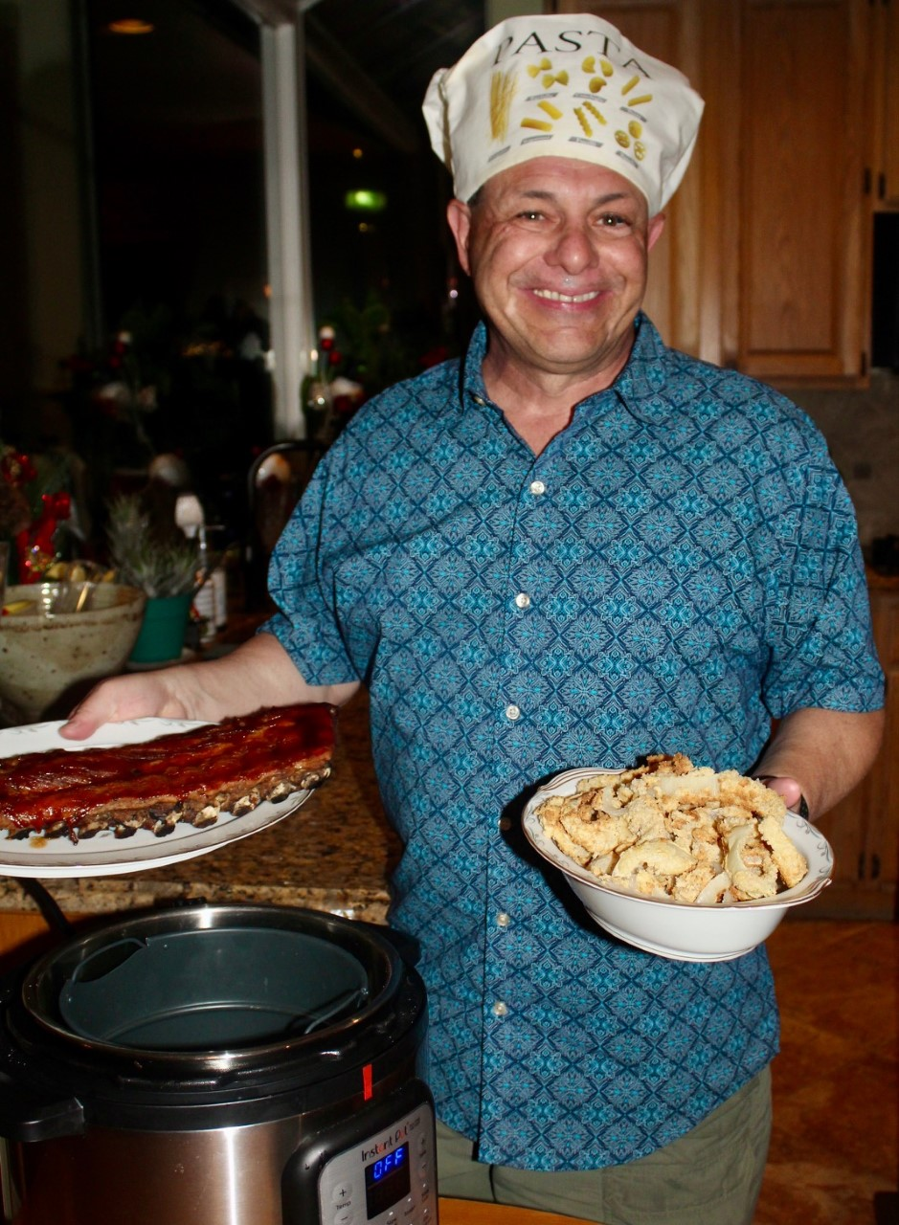
For the cook, I added 2 quarts (qt) apple juice and ½ cup apple cider vinegar to the Instant Pot, then the ribs with the bone side facing the center, and additional water up to the top of the ribs. The ribs were pressure cooked on high for 35 minutes (the ribs were thick and meaty, normally I cook for 30 min) with a 10 min natural pressure release and then a quick release. Another option would be a partial cook in a smoker for an hour or two to develop a smoke ring and then finish cooking in the Instant Pot for 15-20 min of pressure cooking with a 10 min natural pressure release

Rico Cassoni, Taste of Wine and Food Tech
Director/Writer and Instant Pot Chef showing a
rack of baby back ribs and onion rings.

and then a quick release. While the onion rings were cooking (see below), I basted the bottom of the ribs with Sweet Baby Ray’s and cooked in a 400º F oven, then flipped, basted, and baked for another 10 min.

While the ribs were cooking, it was time to make the onion rings. This recipe is based on Pressure Luck Cooking Jeffrey Eisner’s recipe. Slice 1 sweet (Vidalia) onion in ¼ inch thick slices, separate, and place the onion rings in a large, shallow bowl and then pour 1qt buttermilk over them, cover, and refrigerate for 2 hours. The buttermilk soak is a key step to tenderize the onions. When ready to cook, take the buttermilk-coated onion rings out of the fridge. In one bowl, the dusting bowl, add 1 cup flour, 2 tsp seasoned salt, 1 tsp garlic powder, 1 tsp onion powder, 1 tsp baking powder (for puffiness and crunch), and 2 tsp black pepper then whisk to combine. In a 2nd bowl, the beer batter bowl, add 1 cup flour, 12 oz beer (amber or lager), and 4 tsp Sautéed Onion Better Than Bouillon and then whisk to combine. One by one, dip an onion ring into the dusting bowl to fully coat it and then dip in the beer batter bowl, allowing any excess to drip into the bowl. Add to the air fryer allowing room for air to circulate and cook on 375deg for 17 min.

I love having Syrah with pork. After digging through my collection, I decided on a 2013 Carruth Cellars Sonoma Valley from Hershberg Vineyard with great fruit and Syrah jaminess, medium tannins, and a nice long finish. carruthcellars.com.

Luckily, there was enough Syrah left to enjoy with the Chocolate Lava Cake topped with Vanilla Ice Cream. As a reminder, here is the lava cake recipe. Melt 1 cup of chocolate chips (dark if possible) and 1 stick of butter in a microwave for 30 sec, stir, and then for another 30 sec, stir until smooth. In a separate bowl, whisk 3 eggs, 1/3 to 1/2 cup sugar, ¼ cup all-purpose flour, and 1 tsp vanilla. Next, pour the chocolate mixture into the egg mixture and stir to combine. Grease four ramekins with butter or cooking spray. Fill each ramekin 2/3 full. Put a trivet in the bottom of the Instant Pot along with 2 cups of water. Put three ramekins on the bottom and the fourth on top of the three. Pressure Cook for 8 min and quick release. Use a paper towel to soak up any water on the edges. Bon Appetit!

Story by Tech Director/Writer (and Instant Pot Chef) Rico Cassoni

Frank Mangio is a renowned wine connoisseur certified

by Wine Spectator. He is one of the leading commentators

on the web. View his columns at tasteofwineandfood.com.

Go to recent columns. Reach him at frank@tasteofwineandfood.com

