
TASTE OF

WINE & FOOD

By Frank Mangio

Week of May 23, 2020

Catena Zapata Takes You Higher

When one thinks Malbec, hopefully they are thinking of fruit grown high in the mountains of Mendoza, Argentina. Mendoza is the Malbec capital of the world and just so happens to be the home of Catena Zapata vineyards. Senior Editor Frank Mangio and I were excited to attend a Catena Zapata Wine Dinner at Sal Ercolano’s West End Bar & Kitchen with Winebow Imports, Andii Ulrich, WSET Advanced, narrating the evening. It was only fitting that Chef Noe teamed up with Ercolano’s good friend Jose Luis, a Sommelier and Chef, from Canete, Peru to prepare the five course dinner paired with Catena Zapata wines.


Catena Vineyards was started in 1902 when Italian immigrant Nicola Catena founded and built the winery in 1902. Catena is famous for resurrecting Malbec from phylloxera that destroyed Malbec vines in France. Second Generation was Domingo Vicente (DV) Catena. When DV went to Buenos Aires, the Argentine capital and noticed its fancy Parisian-styled restaurants, he saw a wine market waiting to be conquered. This inspired DV to create TINTO BUENOS AIRES, a blend of Malbec, Bonarda and Petit Verdot which quickly became Argentine table

(Left)West End Bar & Kitchen Proprietor,
Sal Ercolano with Winebow Imports, Andii
Ulrich holding a 2016 Nicolas Catena Zapata
Cabernet/Malbec Blend.

wine in restaurants and homes. Today’s Catena Zapata is overseen by third generation Nicolas Catena Zapata and his daughter Laura Catena. His Catena Dream was “to make Argentine wines that can stand with the best in the world” and he is credited with transforming Argentina wines. Inspired by the Napa revolution of the 1970’s, 80’s, and by the Judgement of Paris, Nicolas knew to make a difference, he needed to search for cooler climates further South and higher in altitude than traditional vineyards. After doing exactly this, he is justly credited with putting Argentinean wines on the world stage with the best of the best. In fact, Wine Enthusiast named Catena Zapata as the “New World Winery of the Year” in 2010 and Wine Spectator awarded Nicolas with a Distinguished Service Award in 2012 for his efforts to raise Argentina wine quality and earn worldwide recognition. Additionally, Nicolas created the Catena Institute in collaboration with the University of California Davis and Universidad Nacional de Cuyo. The Institute provides leadership for the university research and development programs to advance and promote wine knowledge for the benefit of wine technicians and the wine community.

Back to the dinner, Ulrich did a fabulous job explaining the different categories of Catena Zapata wines over the five course dinner. For example, the evening kicked off with Chef Noe and Chef Luis mini bites paired with 2018 Catena “Tupungato” Chardonnay from the Appellation Catena collection from single appellations. The high altitude (5,000 feet) where the fruit is grown promotes crisp minerality and rich fruit profiles with low alcohol and was definitely true with the Chardonnay. Next up was a Beef Empanada served with D.V. Catena in homage of Domingo featuring the original Malbec (72%), Bonarda (also known as Charbono-21%), and Petit Verdot (7%) blend. A balanced red blend combo accenting the empanada spices and flavoring. The third course was Leg of Lamb served over polenta and melted mozzarella paired with 2017 San Carlos Cab Franc also from the Appellations collection. The 100% Cab Franc is aged 12 months in the barrel with 35% new French oak. The sandy loamy soils and altitude create nose and palate of ripe fruit with hints of eucalyptus and black pepper and a long, smooth tannin finish.

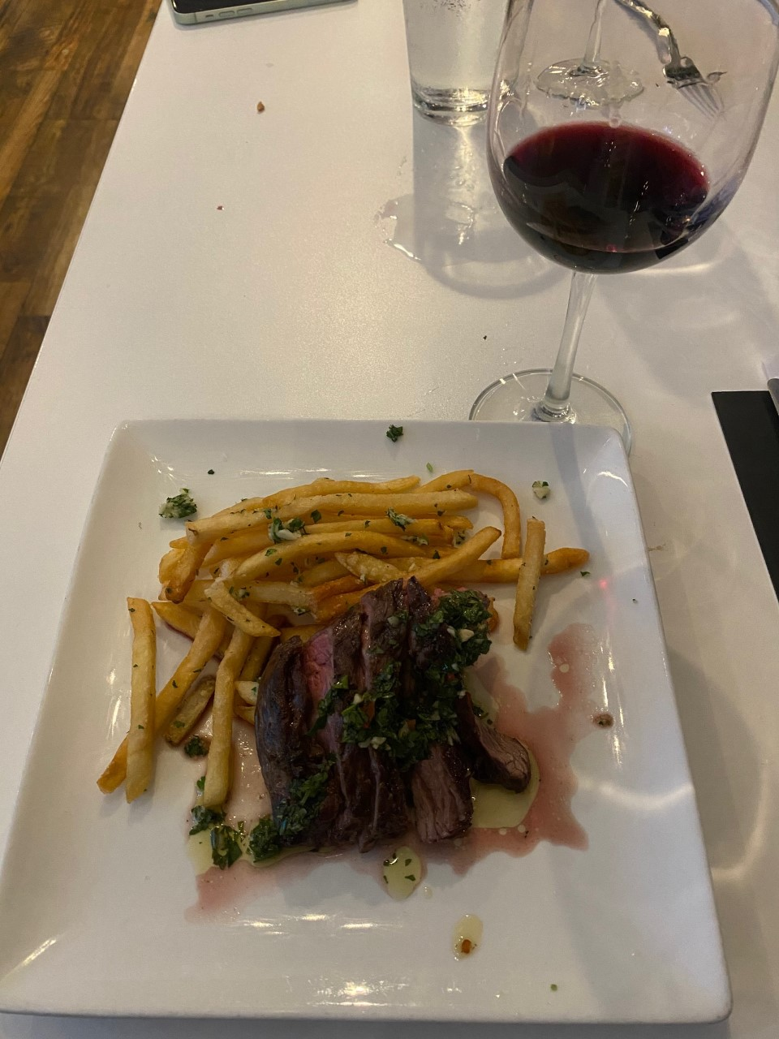
The main course featured grilled skirt steak topped with chimichurri sauce alongside papas fritas (French fries, garlic, and parsley) paired with 2016 Catena Alta Historic Rows Malbec. The Catena Alta category has lot-by-lot selections of fruit from historic Catena sites. This 100% Malbec is aged 18 months in 30% new French oak 225L and 500L barrels. Ulrich spoiled the guests with a bonus 2016 Nicolas Catena Zapata pouring, from the Catena Zapata category. This premium category has plant by plant selections marked with a red sash on the plant in the field and is the best fruit that Catena has to offer. This Cab Sauv

Grilled skirt steak topped with chimichurri
sauce alongside papas fritas paired with
2016 Catena Zapata blend.

(59%), Malbec (33%), and Cab Franc (8%) blend was a stunning pairing proving at least to me that Catena is a premium wine. Dinner concluded with chocolate pudding served with an Australian Yalumba Antique Tawney port. A great evening of wines, food, and narration. Bravo Sal, Andii, Chef Noe, and Chef Luis! More details and info at catenazapata.com and westenddelmar.com.

Story by Tech Director/Writer Rico Cassoni

Wine Bytes

The WineSellar Brasserie in Sorrento Valley San Diego presents two Carol Shelton Wine dinners Fri. June 4 and Sat. June 5, both at 7pm. Carol’s known as the Zen of Zin with her focused and sophisticated Zinfandels and will be in attendance to share her lovely wines with chef’s perfectly paired courses. RSVP at 858-450-9557 for pricing and availability.
Flora Bar & Kitchen in Carmel Valley San Diego is pleased and excited to present “Italian Night” Thurs. June 17 at 6pm with a special engagement by Rosario Monetti, live and in person. Mr. Monetti is well known as a famous opera and Jazz singer. He is also Music Director of the San Diego Italian Film Festival. Flora has crafted a special five course dinner + two glasses of wine for just $90 per person, all inclusive. Call 858-461-0622 to reserve your table.

Frank Mangio is a renowned wine connoisseur certified

by Wine Spectator. He is one of the leading commentators

on the web. View his columns at tasteofwineandfood.com.

Go to recent columns. Reach him at frank@tasteofwineandfood.com

