
TASTE

OF

WINE
By Frank Mangio

Week of March 22, 2020

Order Food to Go – Help Save a Restaurant

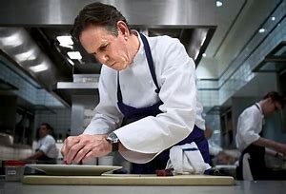
Restaurants are in a world of hurt since the Pandemic Coronavirus closed all restaurants and other establishments that serve food on-site in California and other states. From Master Chef Thomas Keller with his 13 world renowned restaurants from Napa Valley to Miami, to the corner pizza place, restaurants can no longer serve diners at their tables on-site.

Thomas Keller, one of the world’s great master chefs,

originated magnificent dishes at the legendary

French Laundry in Yountville, Napa Valley.

California government guidelines that were received Monday March 16th are explicit. “All restaurants and other establishments that serve food shall close on-site dining. Food service shall be by delivery, pick-up or drive-through.” As far as I can research it, wine shops, wineries and restaurants that did so prior to this directive, cannot offer wine tastings. A good many have chosen to shut down.

Today I placed an order for take-out food for the evening of this writing with a local, recently opened “fast casual” American style food restaurant, that specialized in take-out. I was told to stay in my car and not enter the restaurant.

Instead I was to call the restaurant phone and a server would come to the car, a small inconvenience compared to all that this restaurant was faced with.

What’s the big national picture? No less a figure than master chef Thomas Keller, who started the super successful French Laundry in Yountville, Napa Valley, and blossomed into 13 highly recommended fine dining locations like Los Angeles, Las Vegas and Miami, went on CNBC Business News for the Restaurant Association of America. “5 to 7 million restaurant and supplier workers may be out of work, from an estimated 15.5 million nationally. Since March 1, business has gone from normal to near zero,” he lamented.

Local San Diego chef/celebrity Brian Malarky, A “Top Chef” finalist and owner of Herb & Sea in Encinitas, reportedly closed all 9 of his restaurants in San Diego county and one in nearby Irvine, affecting several hundred workers.

We can help. Call your favorite restaurant, ask about specials or your go-to menu entrée for pickup when you arrive. Most will bring you your order curbside, or deliver your choices to your home. For instance, the Il Fornaio Italian restaurants are offering a “Family Feast,” a four course dinner for 4, ready for take out or delivery for $70. Morton’s the Steakhouse discounts their entrees 10% when you bring it home. Vittorio’s in Carmel Valley San Diego is offering a family & friends discount of 30% on all menu items, take out or delivery.

For all our restaurant, hotels & winery friends, please send us your take out/delivery information and we’ll do our best to publicize it during this shut-down. Send to info@tasteofwineandfood.com. As my friend, owner Randy Smerik at Solare Italian Restaurante in Pt. Loma San Diego likes to say, “Food is the power that brings us together.”

Carruth Cellars 10th Annual Barrel Tasting

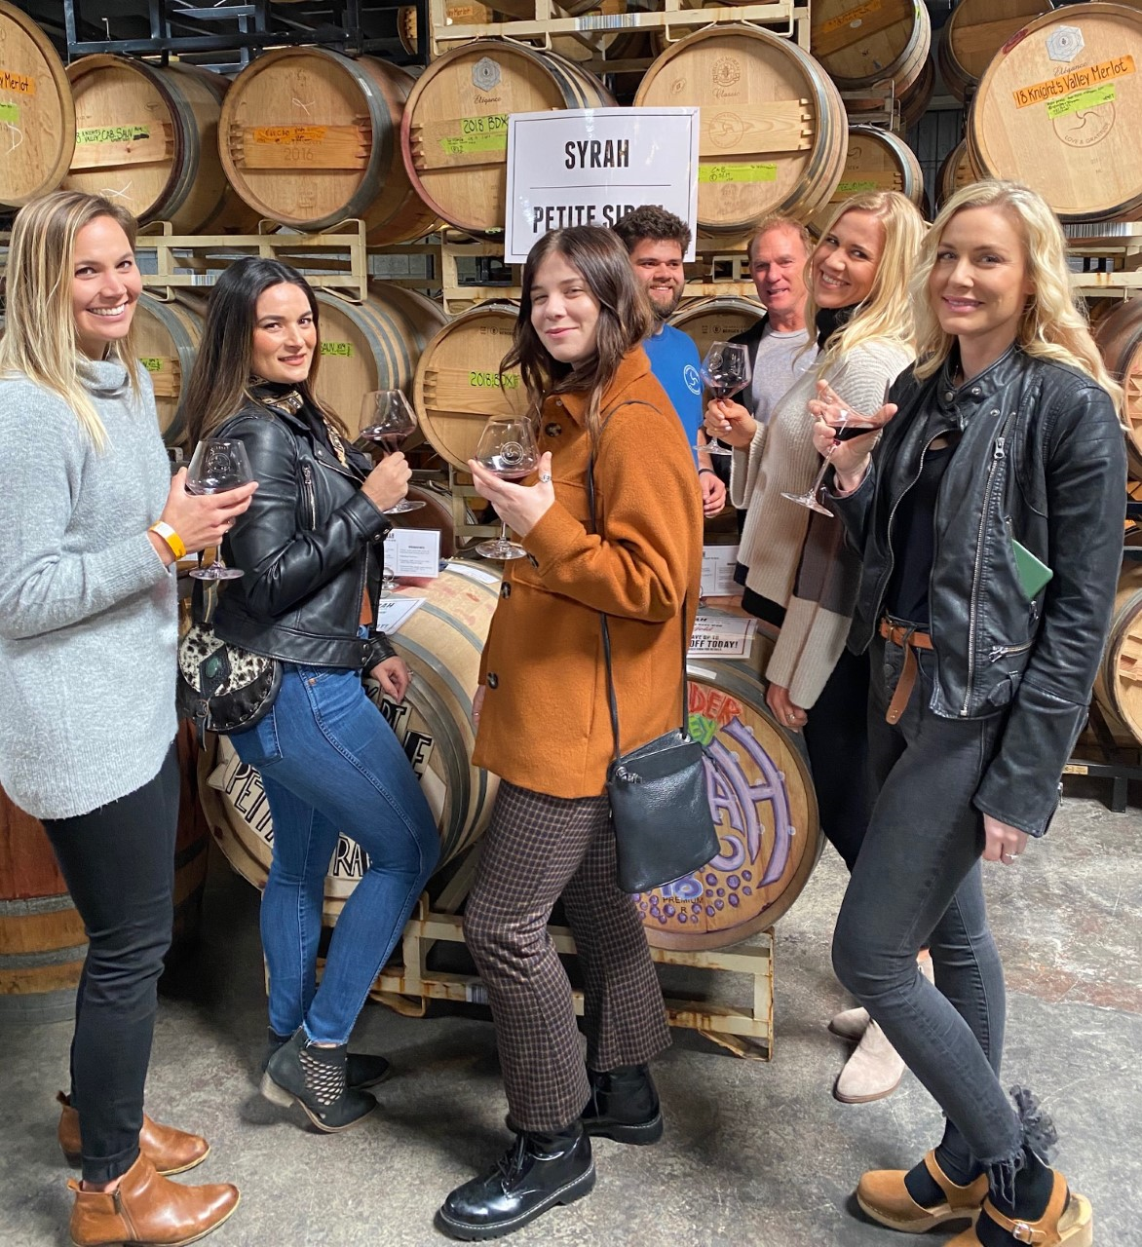
It is amazing how different the world was before Covid-19 emerged. For example, just a few weeks ago, Senior Editor Frank and I were enjoying Carruth Cellars’ 10th Annual Barrel tasting with sold out crowds for two sessions each on Sat and Sun Feb 22 and 23rd before social distancing was part of our vocabulary.

Guests were able to enjoy a baker’s dozen (13) of barreled wine samples served from a wine thief. Samples were pulled from barrels where the wine is currently aging before being bottled and then

Good friends enjoying barrel samples of
Syrah and Petit Syrah at Carruth Cellars
10th Annual Barrel Tasting

further aged. Attendees were greeted with a Sauvignon Blanc and then had 12 reds to choose from at one of San Diego’s first urban wineries. These are wineries that buy fruit from suppliers and then take over to both make the wine and get into the hands of consumers. Proprietor and Head Winemaker Adam Carruth was kind enough to walk us around the stations. We were even able to create and try some blends with Carruth including a tasty 40% Zinfandel, 30% Syrah, and 30% Cabernet Sauvignon (Cab Sauv) blend. The 2018 Pine Mountain Cab Sauv was delicious along with the BDX Bordeaux blend of Merlot, Cab Sauv, Petite Verdot, and Cab Franc. The Pine Mountain Cab Sauv and BDX blend were our two favs of the day, being served by asst winemaker Steve Michaliszyn. Congrats to Adam Carruth and the team on this hugely successful event. Along with delicious wines, guests were able to purchase Neapolitan pizzas with perfect leoparding.

Carruth Cellars is still open with limited hours of operation and offering pick up service via partners Mon-Sat 4:00 to 8:00PM and Sunday 2:00 to 6:00PM. Please support Adam, his employees, and their food partners in these challenging times as my colleague Frank mentions above. Visit carruthcellars.com. Story by Tech Director/Writer Rico Cassoni.

Challenging Times Require Creative Solutions

During these unimaginable times resembling fictional Sci Fi movies, it is key for societies to maintain human interaction, and comply with stay at home mandates. The wine industry has stepped up to provide creative opportunities via virtual wine tastings and social sessions to add levity. Here are a few examples that we have heard of and even participated in.
- Enriquez Wines, a small, family-owned Napa Valley vineyard is providing virtual wine tastings with owner and winemaker Cecilia Enriquez. Just purchase any 6 mixed bottles or more and receive $1 shipping on your order along with your virtual tour.
- Solare Ristorante Italiano started a “Solare LIVE" online streaming channel. Folks can hang out at home and interact with Proprietor Randy Smerik and the Solare Team. On Fri Mar 20, Sommelier/Event Coordinator Petra Belliti led a LIVE fun interactive session on Italian wines. On Sat Mar 21, Chef Filippo was LIVE showing how to make their famous Solare Lasagna (epic - rare opportunity). On Tues Mar 24, Tommy had a session on making cocktails and Italian spritzes. Check out future Solare LIVE sessions via Instagram (@solaresandiego).
- DAOU Vineyards also held LIVE Instagram sessions. This included a Fri Mar 20 session with Co-Proprietor and Master Winemaker Daniel Daou along with Social Media Manager & Brand Ambassador Kat Daou. Another session was held on Sun Mar 22 with Co-Proprietor Georges Daou. Check out future Instagram LIVE sessions (@daouvineyards).

Stay Safe and Healthy,

Frank and Rico

Frank Mangio is a renowned wine connoisseur certified

by Wine Spectator. He is one of the leading commentators

on the web. View his columns at tasteofwineandfood.com.

Go to recent columns. Reach him at frank@tasteofwineandfood.com

